**Talha Khalid**

**F2021266625**

**V-04**

**Project Part-02**

**Data Comparison**

1. **1000 Random Even Number**

|  |  |
| --- | --- |
| **Technique** | **Total Collisions** |
| Linear Probing | 402, 386 |
| Linked List Chaining | 321, 297 |
| BST Chaining | 321, 297 |
| AVL Chaining | 321, 297 |

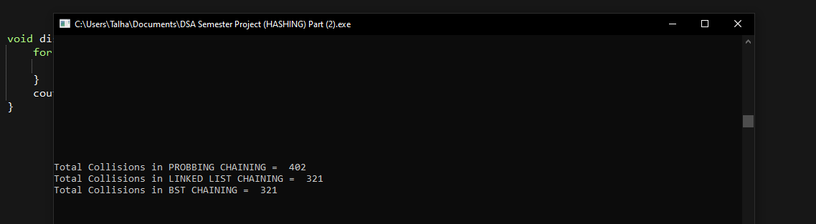

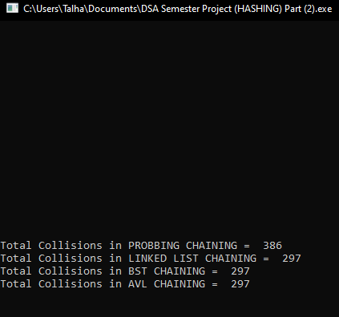

*Mistake in the output **“Linear Probing”** which is a simple implementation of open addressing (not chaining)

|  |  |  |
| --- | --- | --- |
| **Technique** | **Total Numbers Searched/Found** | **Attempts to Search** |
| Linear Probing | 2, 0 | 98, 100 |
| Linked List Chaining | 4, 1 | 77, 69 |
| BST Chaining | 4, 1 | 65, 57 |
| AVL Chaining | 3, 1 | 61, 54 |

1. **1000 Random Odd Numbers**

|  |  |
| --- | --- |
| **Technique** | **Total Collisions** |
| Linear Probing | 401, 386 |
| Linked List Chaining | 321, 297 |
| BST Chaining | 321, 297 |
| AVL Chaining | 321, 297 |

No difference like that of the Even case but 401 comes in the first attempt instead of 402.

|  |  |  |
| --- | --- | --- |
| **Technique** | **Total Numbers Searched/Found** | **Attempts to Search** |
| Linear Probing | 2, 0 | 98, 100 |
| Linked List Chaining | 4, 0 | 77, 83 |
| BST Chaining | 4, 0 | 65, 77 |
| AVL Chaining | 3, 0 | 61, 71 |

1. **1000 Random Prime Numbers**

|  |  |
| --- | --- |
| **Technique** | **Total Collisions** |
| Linear Probing | 424 |
| Linked List Chaining | 341 |
| BST Chaining | 341 |
| AVL Chaining | 341 |

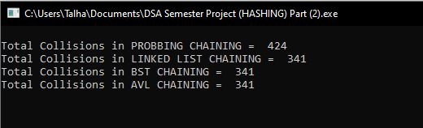

|  |  |  |
| --- | --- | --- |
| **Technique** | **Total Numbers Searched/Found** | **Attempts to Search** |
| Linear Probing | 2, 1, 1, 0 | 98, 99, 99, 100 |
| Linked List Chaining | 2, 2, 1, 1 | 65, 75, 39, 43 |
| BST Chaining | 2, 2, 1, 1 | 49, 57, 38, 35 |
| AVL Chaining | 2, 2, 1, 1 | 47, 59, 38, 33 |

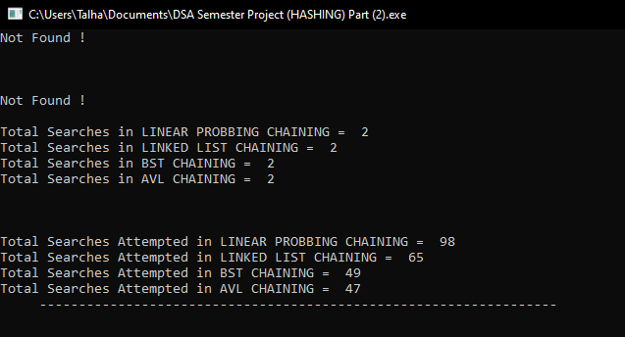

**Which technique is best? State the reason.**

AVL Chaining and BST Chaining give the best results (in terms of time complexity and searching) as compared to linear probing and linked list chaining. If I don’t do more than 2 analyses then, AVL and BST chaining is best. But, if I do more than 2 analyses, I find that **AVL Chaining** gives the best time complexity in terms of searching and insertion than another chaining.

BST and AVL have the same insertion and searching code but AVL got the advantage over that BST, in that it balances the trees, check every node whether the balance factor is out or not and if out, it balances the nodes of trees. AVL stops to make the trees a linked list pattern. The time complexity of AVL in the worst case is O (log n) whereas BST has O (n).